# Sprint 1

## Setting Up our Github

1. Open bash terminal
2. Install brew



1. Install github



1. Idky

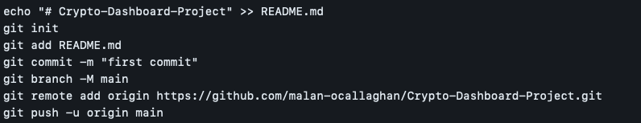

## Setting Up our Backend and Frontend

1. Create a folder called ‘Crypto Dashboard Project’
2. In Visual Studio Code, we open the folder ‘Crypto Dashboard Project’
3. In Visual Studio Code, we open a terminal and perform the following commands in order to… (set up backend – provide reasons for each of these and explain what Flask is)

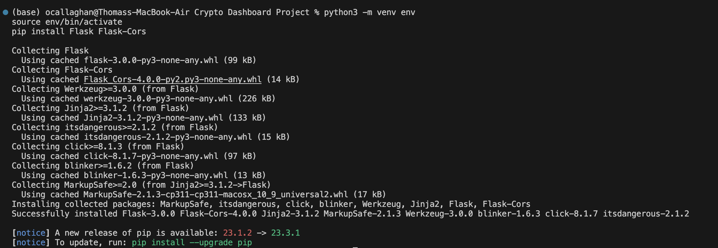

1. In Visual Studio Code, we create a open a new terminal and run the following commands to create our frontend



1. We choose the following vue setup

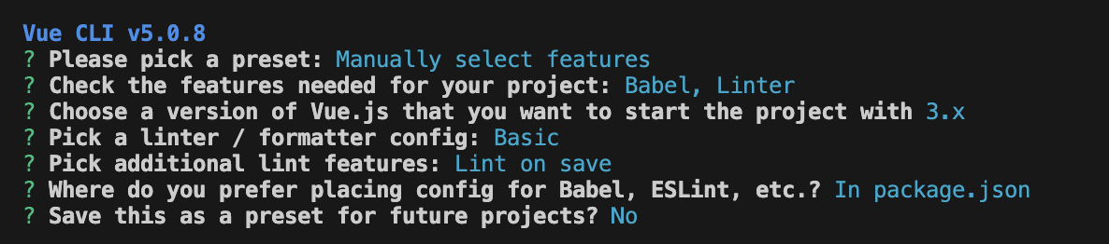

1. We then enter the client folder and add quasar to the vue project



1. We choose to configure quasar as follow:

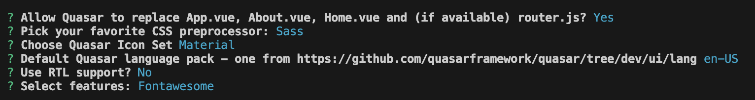

## Establishing Communication between Frontend and Backend

1. Inside the root folder, we create an app.py file that will return a message on the client side. It contains the following code:

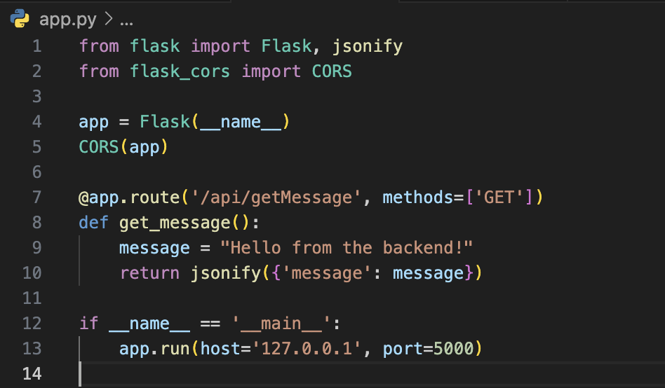

1. We create a component called ‘DummyWidget.vue’ that will receive the message from the backend with the following code:

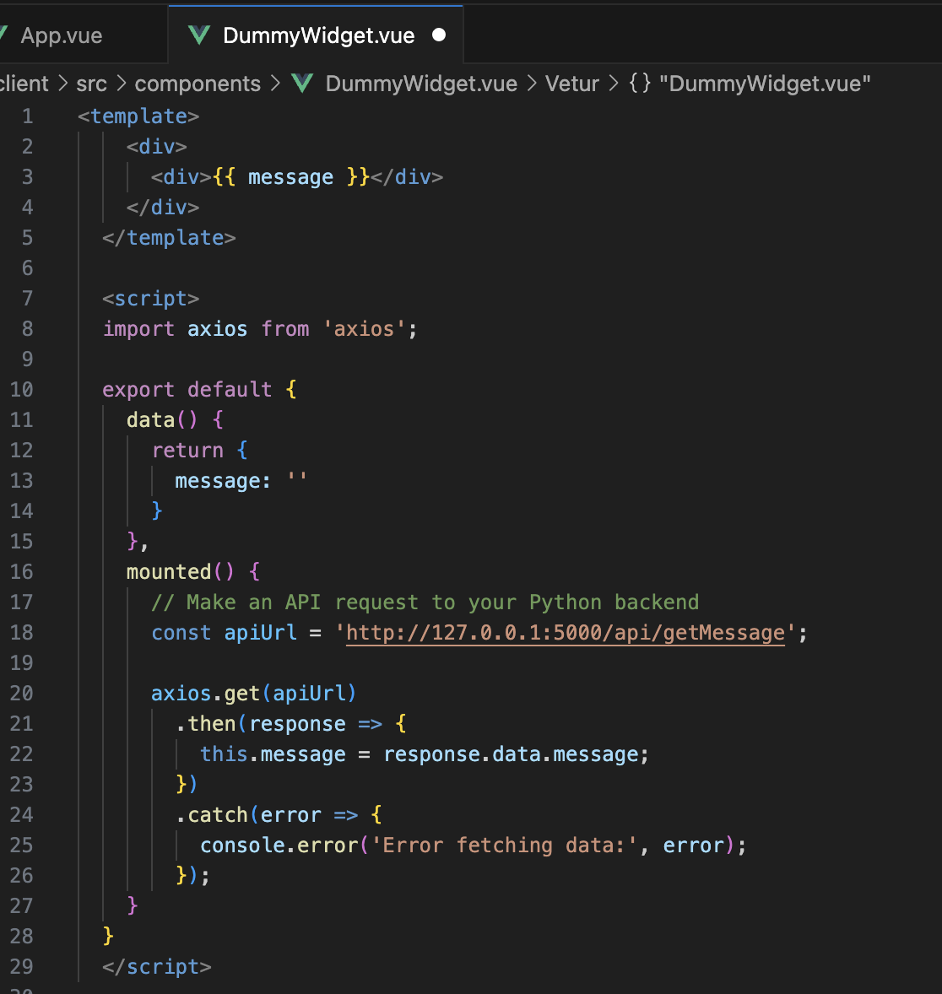

1. We add this component template section to see it.
2. To run the front end we open a server with the following



1. The client server is now running and can be opened with <http://localhost:8080/>
2. To run the backend we open a server with the following in the other terminal

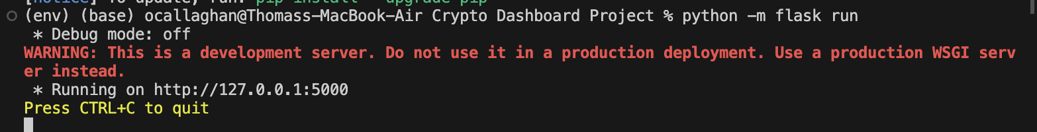

1. The backend server is now running on <http://127.0.0.1:5000>
2. After all of this, we see the following:



## Access to Data

1. Install yfinance python package



1. Update the app.py file to download price data from yfinance.
2. Update the DummyWidget.vue file to get and display price data from yfinance.
3. After all of this, we see

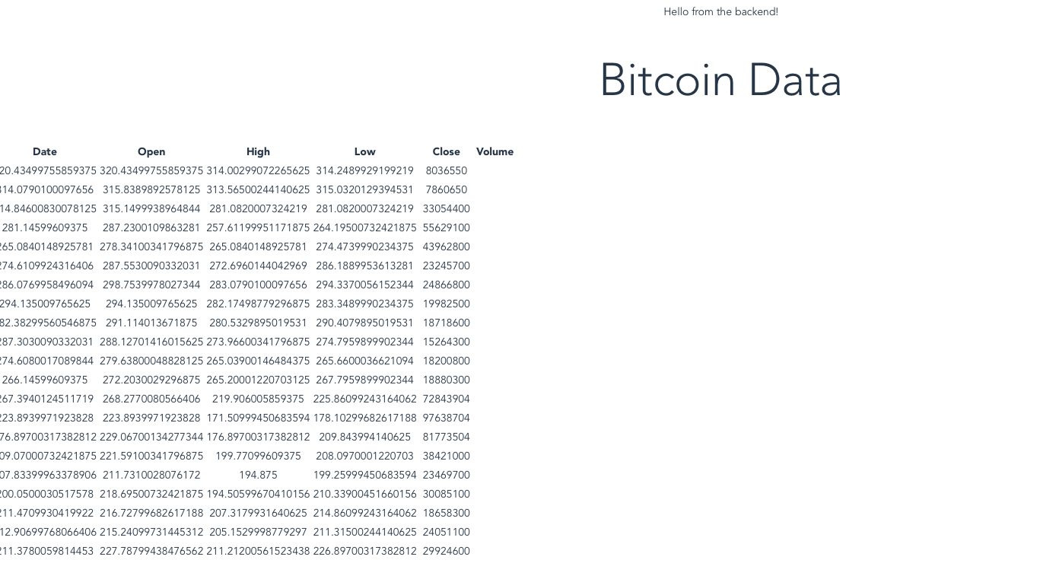

## Allow User Inputs of Specific Data to Show

1. We have added a menu to select specific settings for a widget

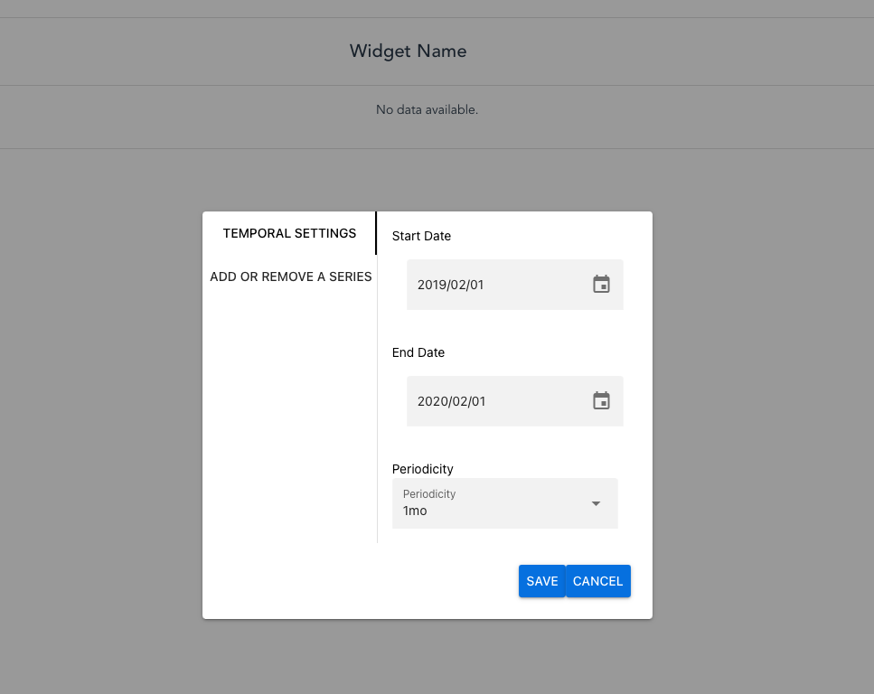

1. We have added the option to add a series/subseries (define properly) to our data that is either downloaded, calculated or aggregated. Each of these have basic mathematical operations/statistical calculations.

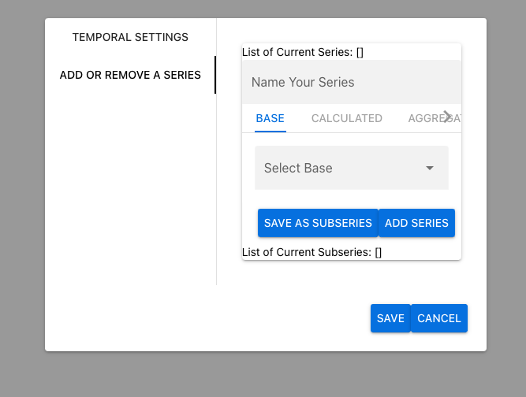

1. In order to remove widgets from the dashboard we have created the following responsive table

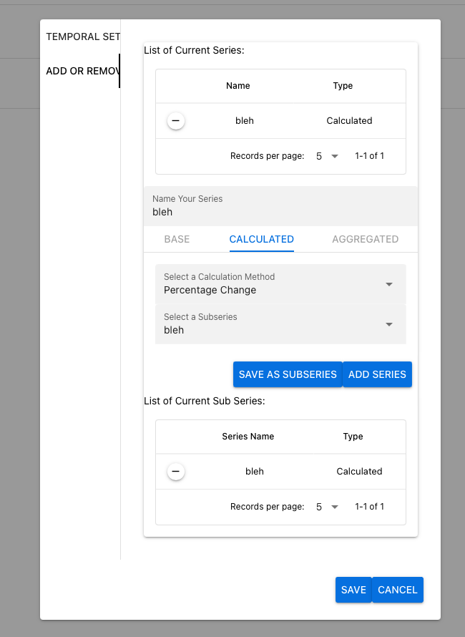

## Data Table Widgets

We have designed a historical and intraday data table widgets. With this menu above, and it allows for the same functionality. It looks like this:

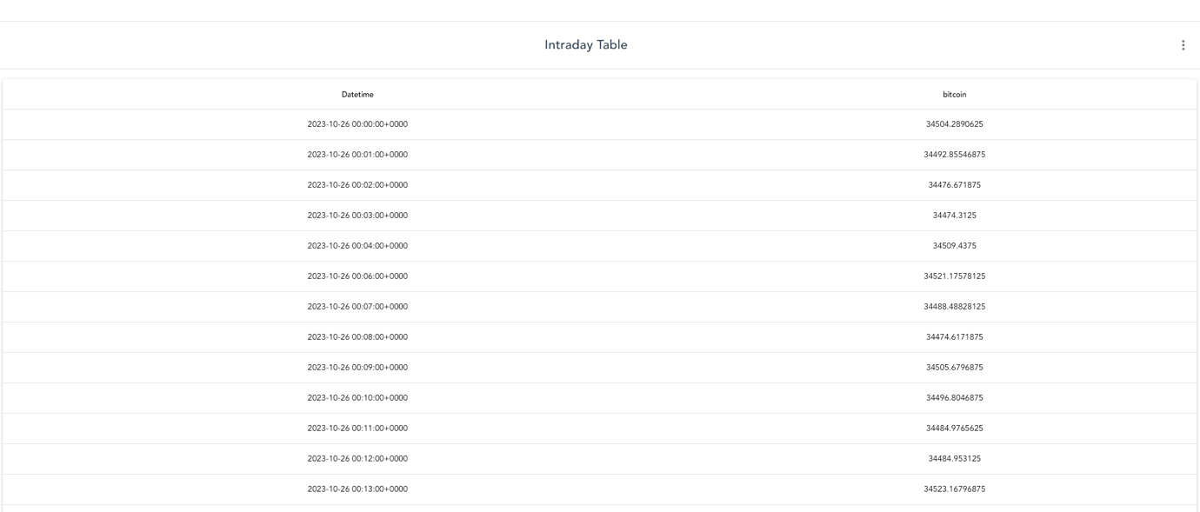

* Developed a Historical Statistics table

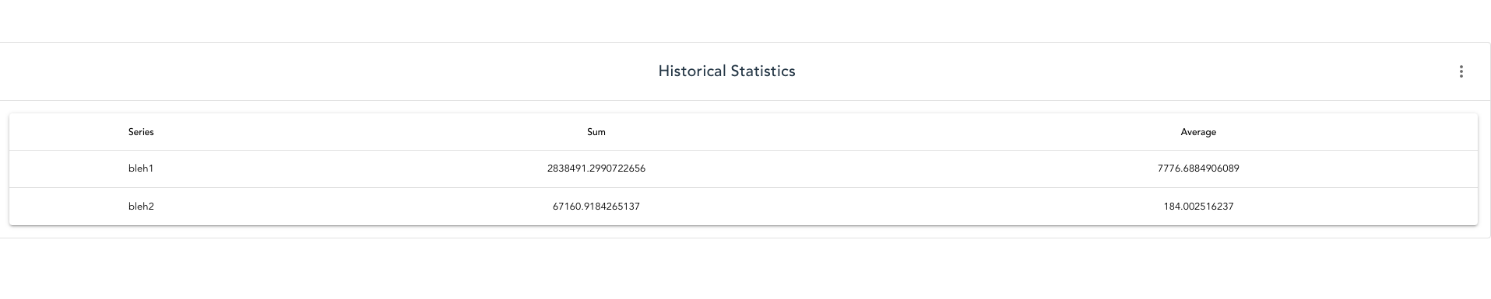

# Sprint 2

## Adding Time Plot Widgets

* Added a time plot for historical time series

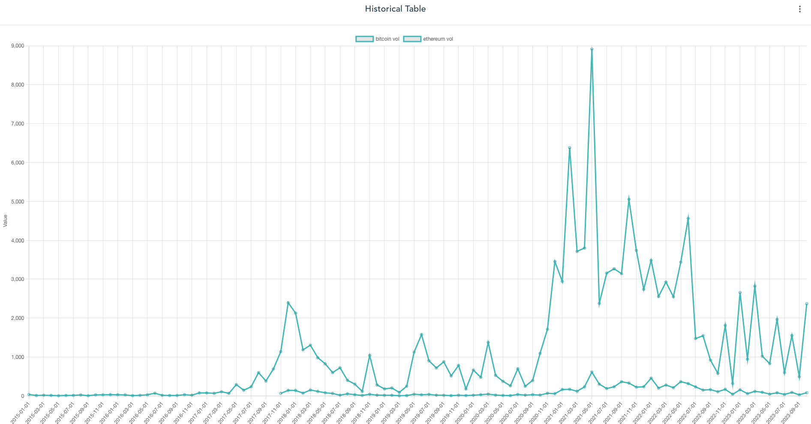

## Adding a Bar Widget

* Added a widget that shows summary statistics between given interval of time as bar chart

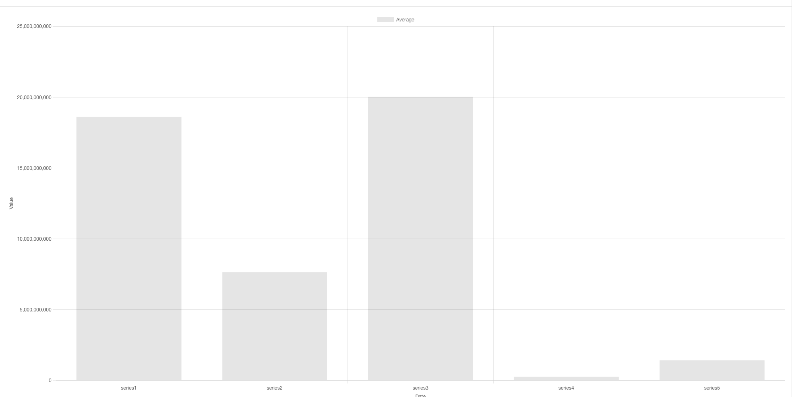

## Adding a Matrix Widget

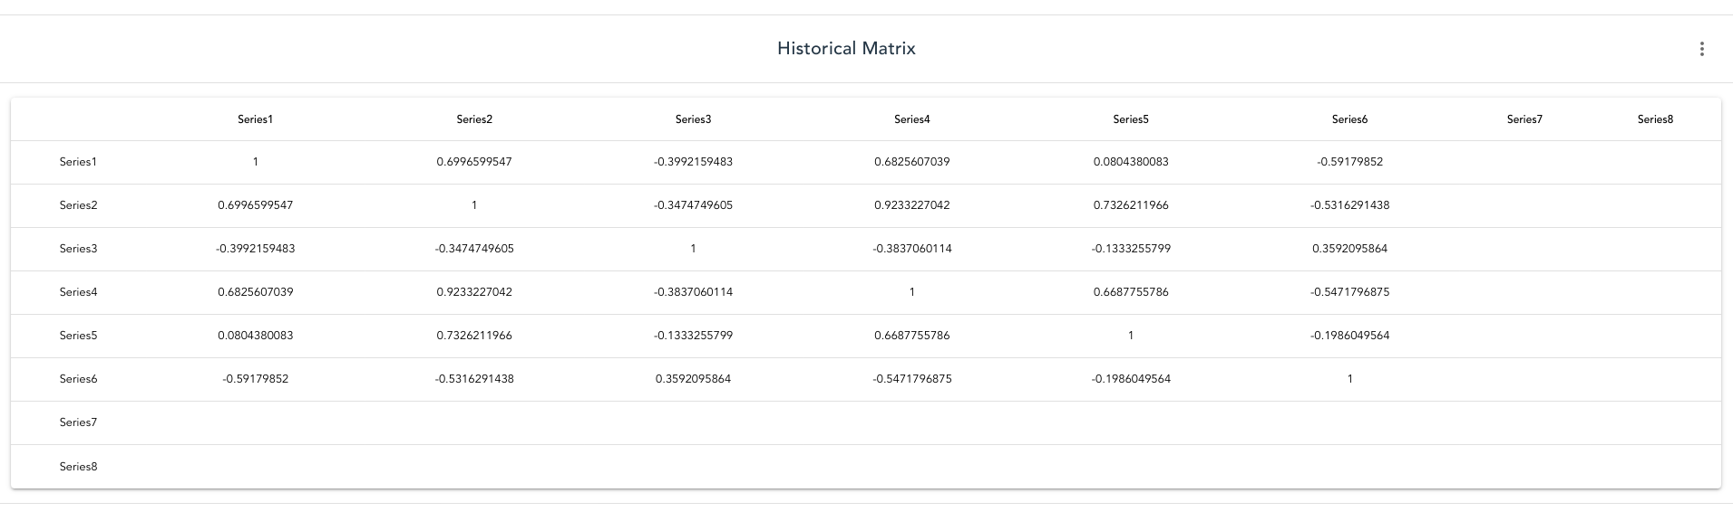

## Created Routes

* I have created a login page – will add authentication logic later.

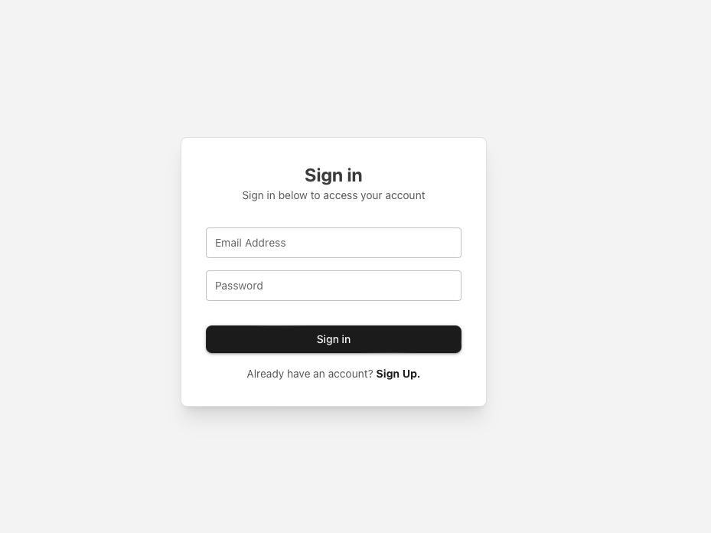

* I have added a registration page – will add registration logic later.

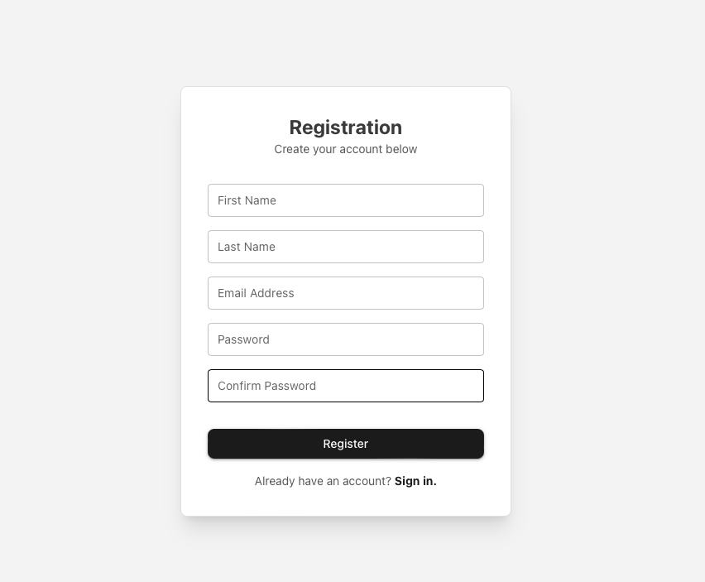

## Creating a Basic Dashboard Setup

* I have created the following dashboard view with the ability to sign out… account management and dashboard management is yet to be added.

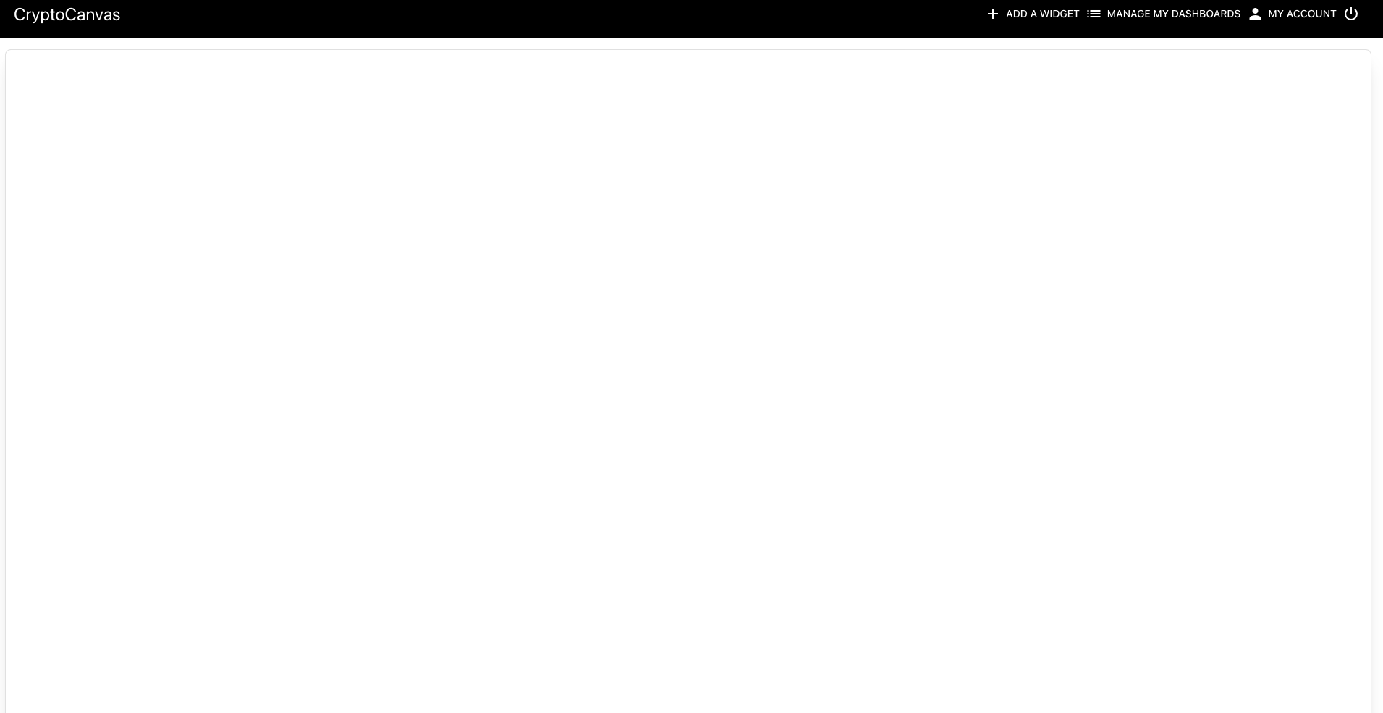

## Allowing Dashboard Editing Functionality

* I have made the canvas area of the dashboard an editable grid that allows for resizing and replacement of items on it.
* I have created a widget menu for users to add widgets to their dashboard. Preview images to be created later.

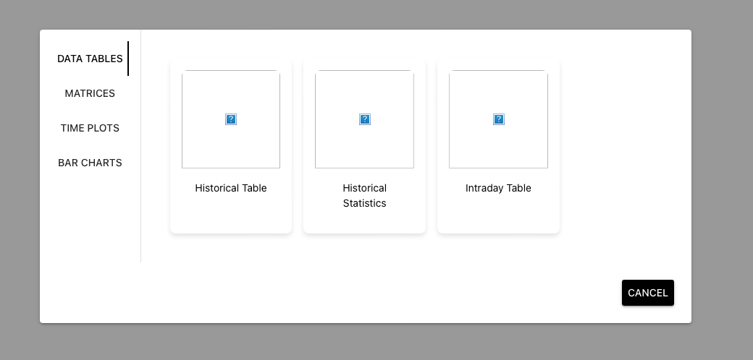

* Added the ability to resize widgets from lower right corner and to remove widgets by dragging them anywhere.

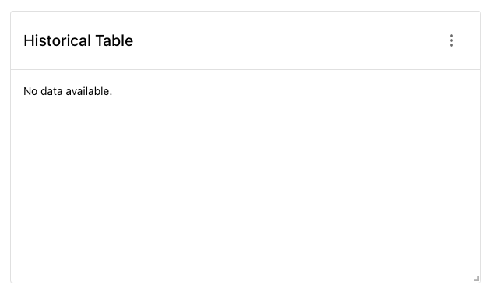

* Added the ability to remove widgets

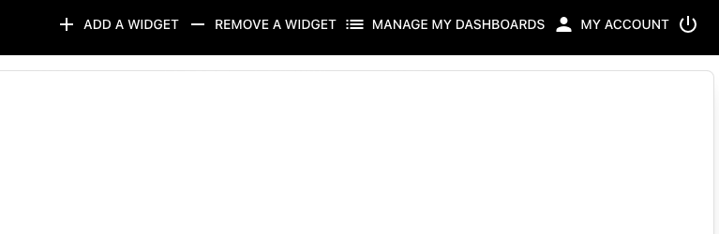

* Improved the UI for editing widgets and added more advanced widget editing options

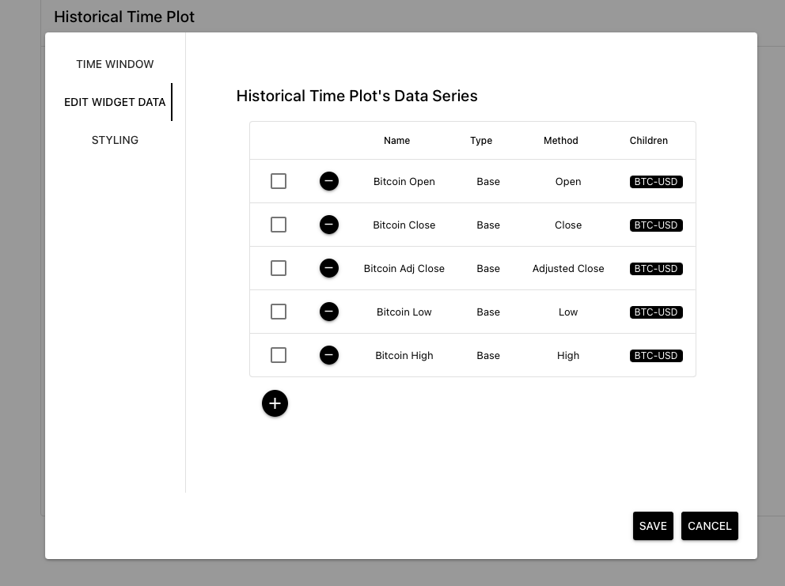

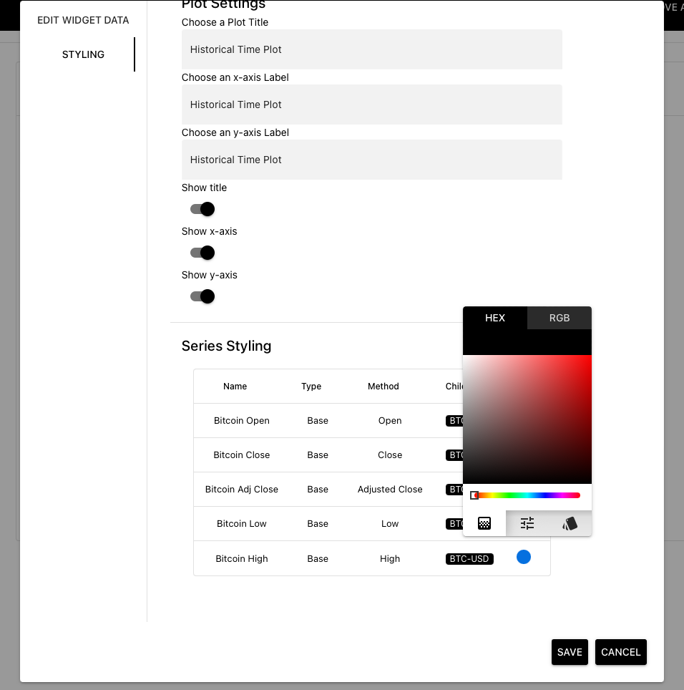

* Added a jiggle effect and highlighted delete mode styling to prevent accidental widget removal

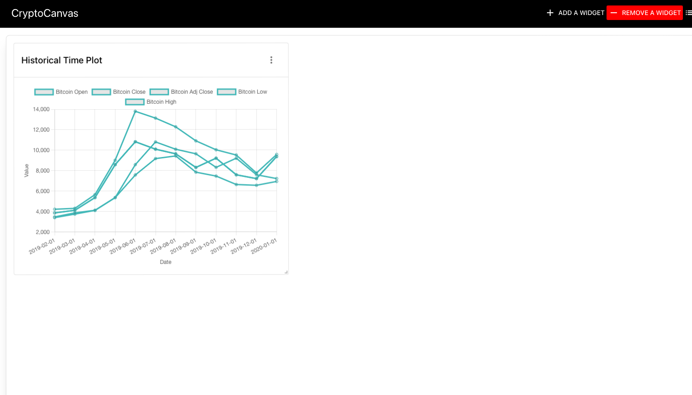

* Added the ability to customize widget styling

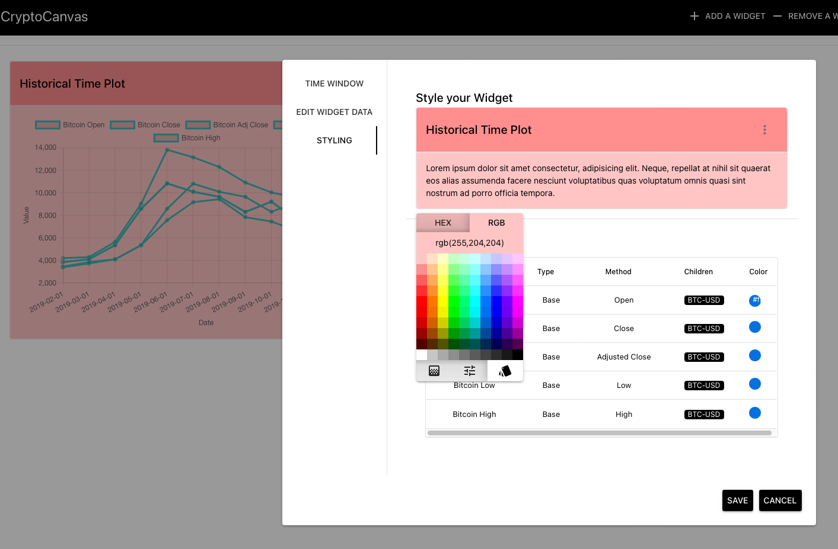

* Added the ability to customize individual data series colors

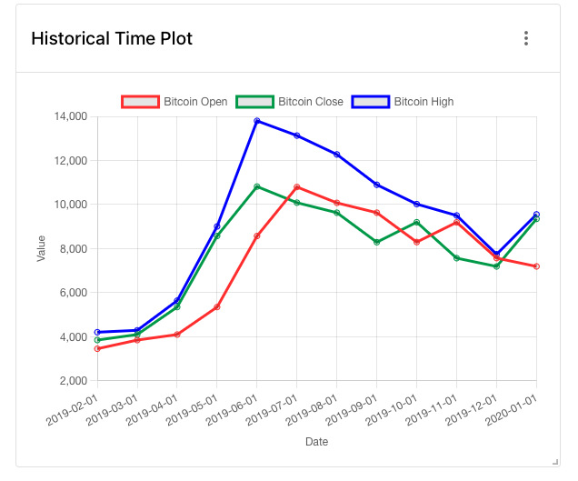

* Separated Edit Widget Data and Styling into separate menus for efficiency

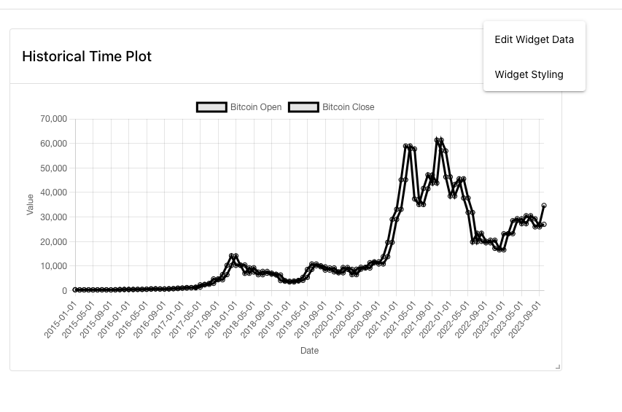

## Updating the Data Table Widgets

* Added the same menu shell to the data table widget
* Allowed for styling for the data table widget

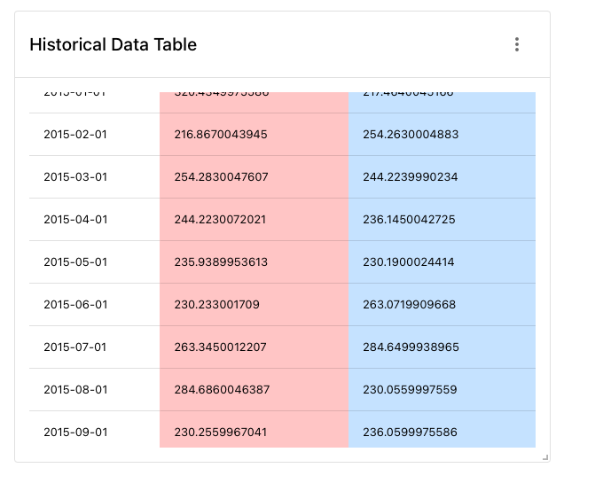

* Updated the Summary Statistics table to the new edit menu
* Added styling options for the summary statistic table

## Configuring Live Functionality

* Added the ability to allow for real time updates of intraday widgets

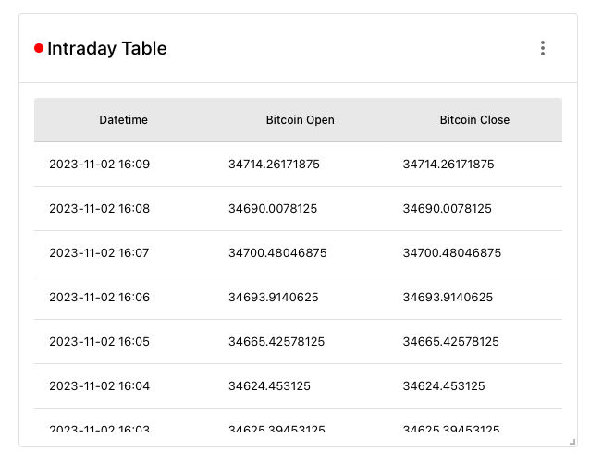

## Pie Chart Widget

Added a PieChart widget

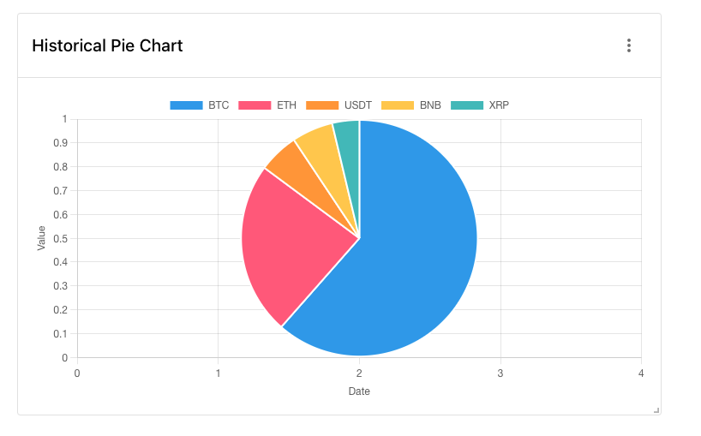

# Sprint IDK

## User Accounts and Authentication

* Setting up the mysql

export PATH=$PATH:/usr/local/mysql/bin

mysql -u root -p

then enter root password password

* Creating the database

CREATE DATABASE cryptocanvasdb;

* Creating the table

CREATE TABLE users (

-> id INT AUTO_INCREMENT PRIMARY KEY,

-> firstName VARCHAR(255) NOT NULL,

-> lastName VARCHAR(255) NOT NULL,

-> email VARCHAR(255) NOT NULL,

-> password VARCHAR(255) NOT NULL,

-> activeWidgets VARCHAR(255) NOT NULL,

-> userDefaults VARCHAR(255) NOT NULL,

-> collections VARCHAR(255) NOT NULL,

-> );

* Added functionality to registration page to record user inputs
* Created an Admin page that shows accounts and ability to remove them

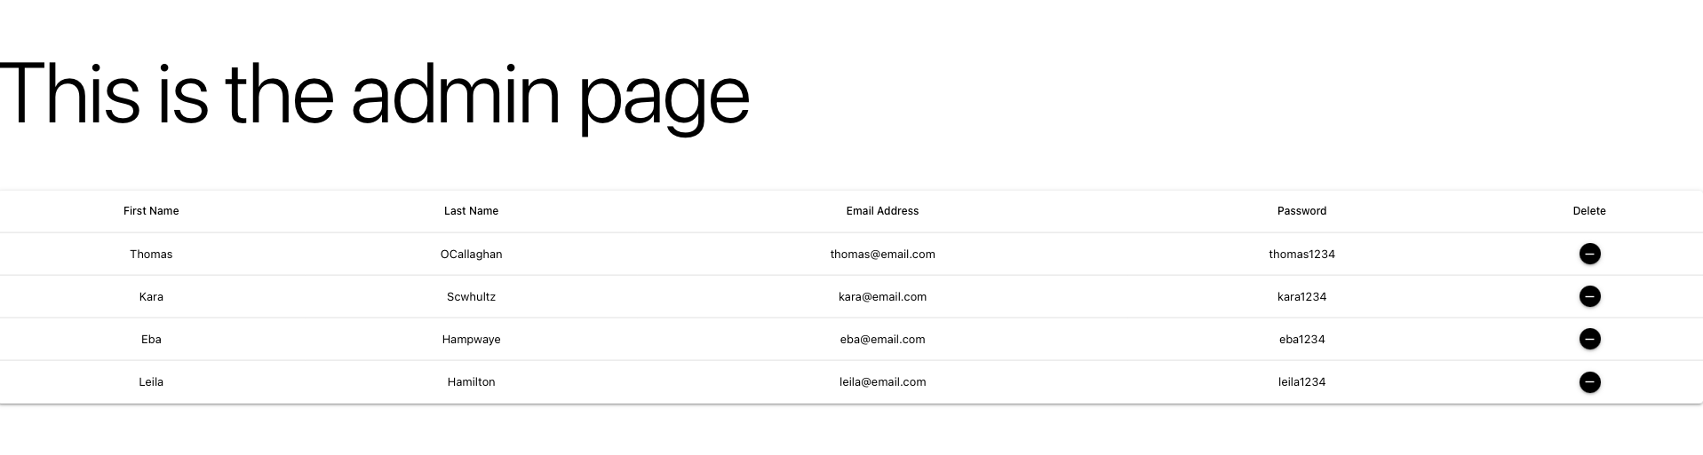

* Added functionality to check password against database

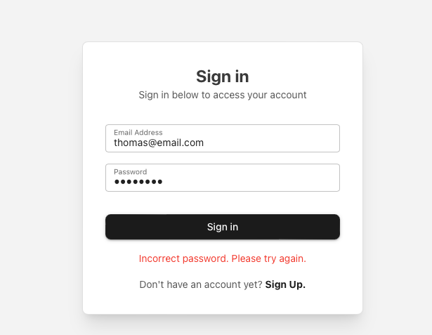

## Storing User Dashboards

* Added the ability to reload user dashboards.

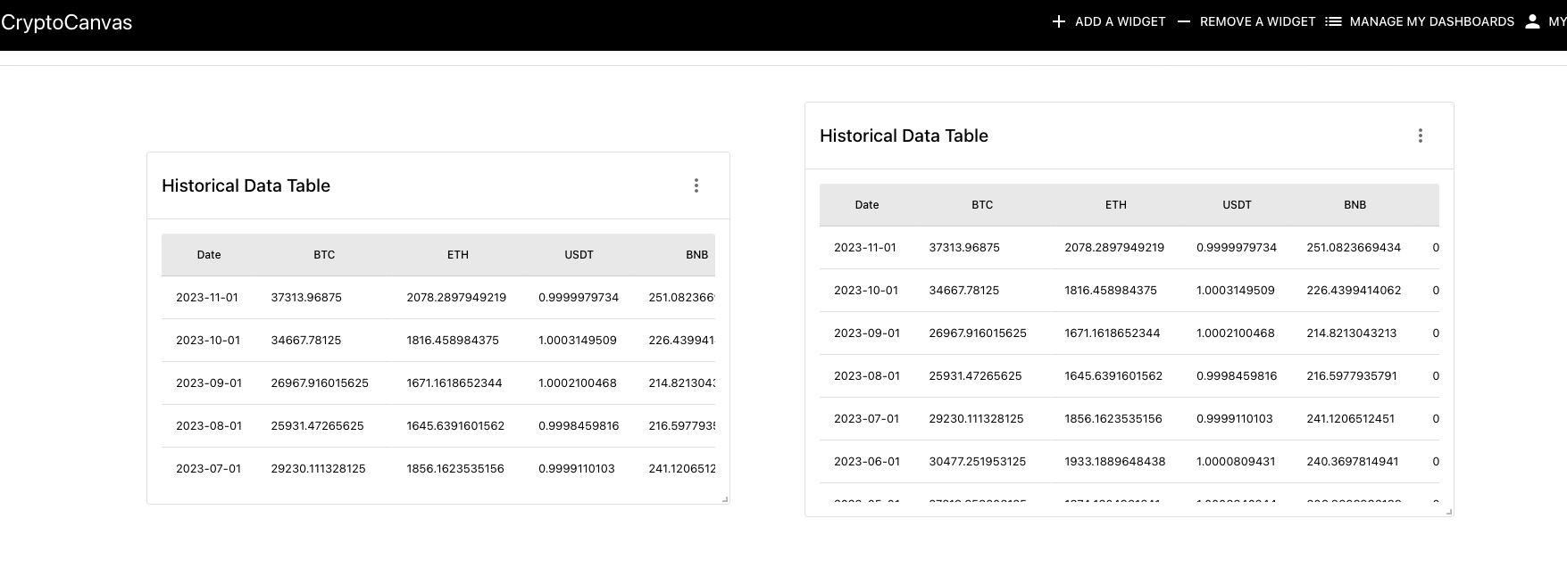

* BUG! Only the default widget gets reloaded without any changes made. Still need to store widget configurations… also their sizes!
* Fixed the bug that axios error occurs when multiple data requests are made at once.

## Adding Functionality to set user Default Preferences

* Added simple functionality to communicate a default value of widget header color to the components. Users can now add new widgets and the default widget header color will be added. However, they can still customize individual widget headers and this save will be stored. Other default functionalities will be based on this logic.

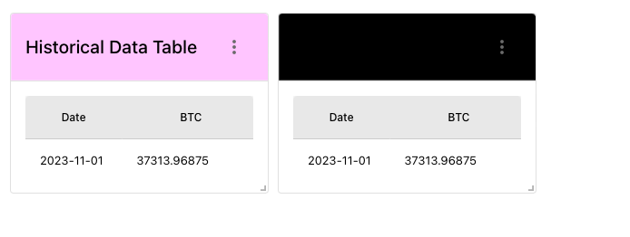

* Have to complete the following defaults and clean up the UI

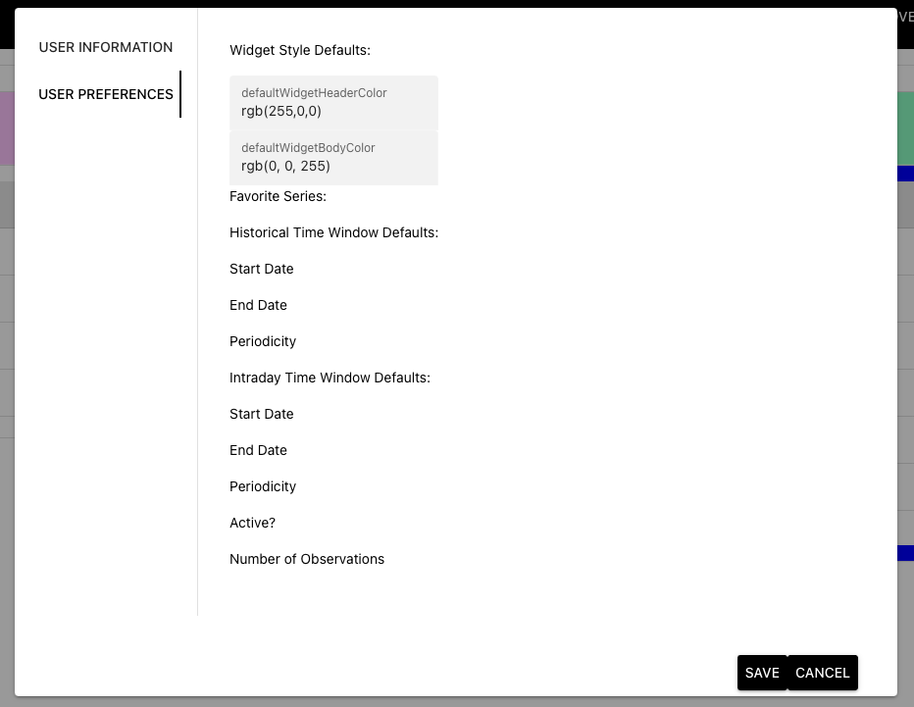

* Also need to do it for the rest of the widgets… only working on the HistoricalTableWidget for now.
* Added Skeletons to widget while data is loading

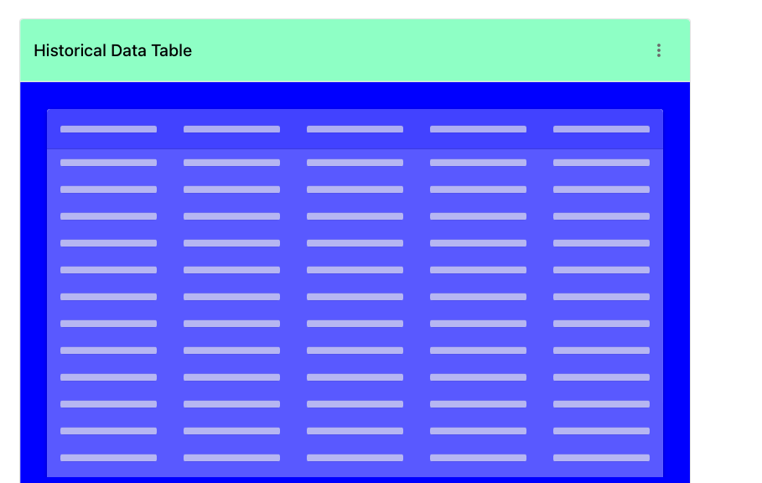

# Some Big Changes and Upgrades

* Merged Sign-in and Sign-up Page into a single welcome page with an improved appearance

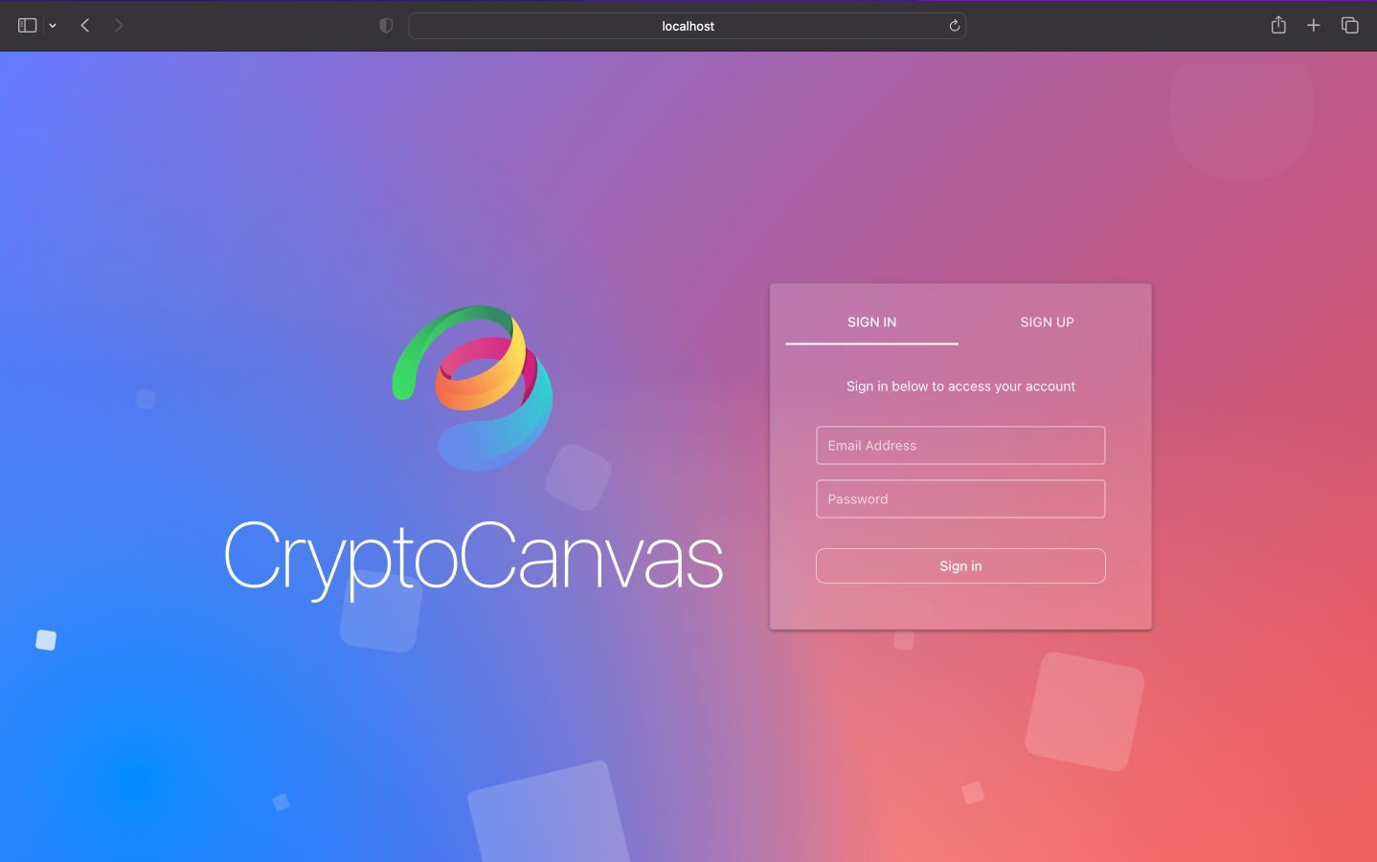

* Allowed users to register and login in if already registered.
* Validations: for login:
  + Unregistered Account

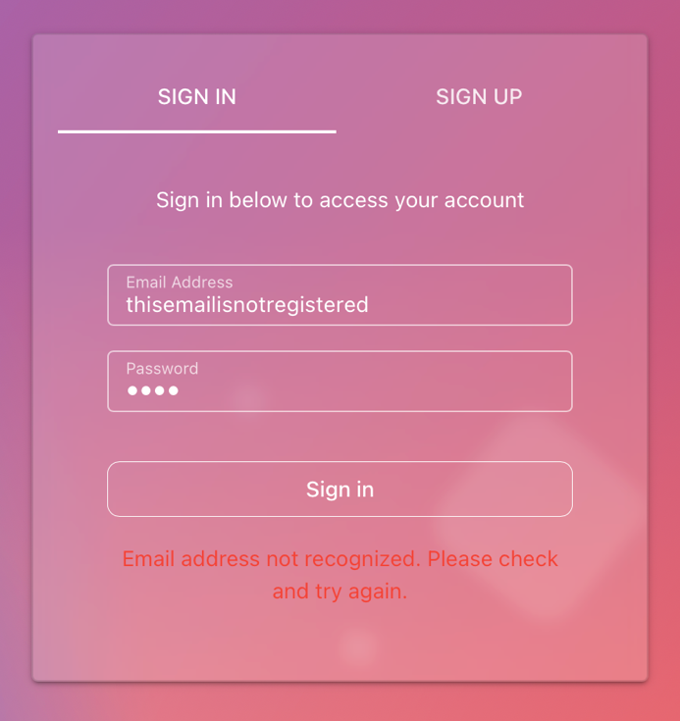

* + Incorrect password

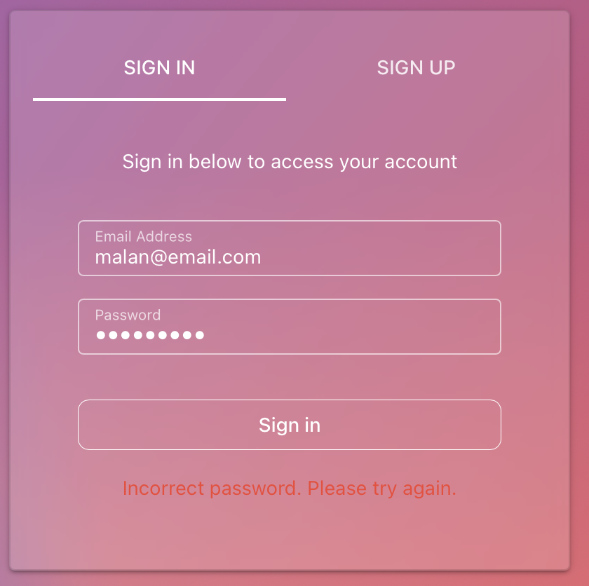

* Validations for registration:
  + Missing fields

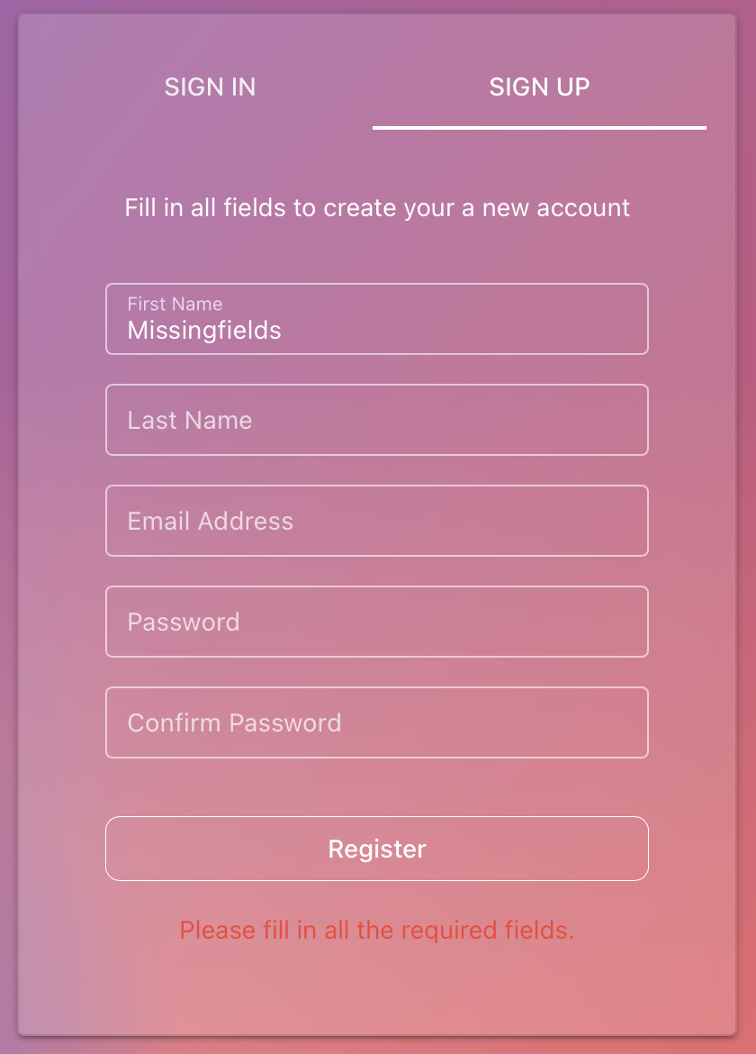

* + User already registered

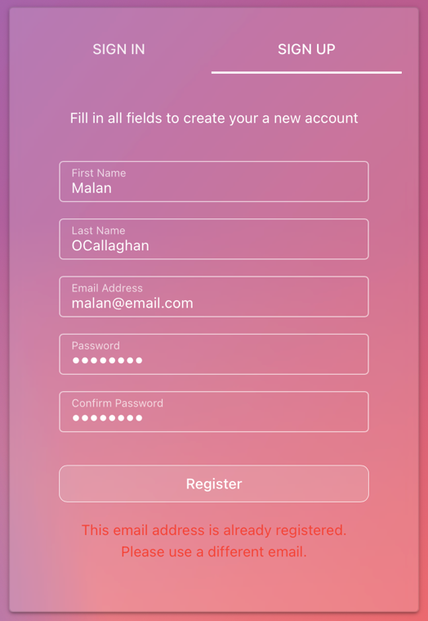

* Added a popup welcome tutorial for first timers (content to be added later)

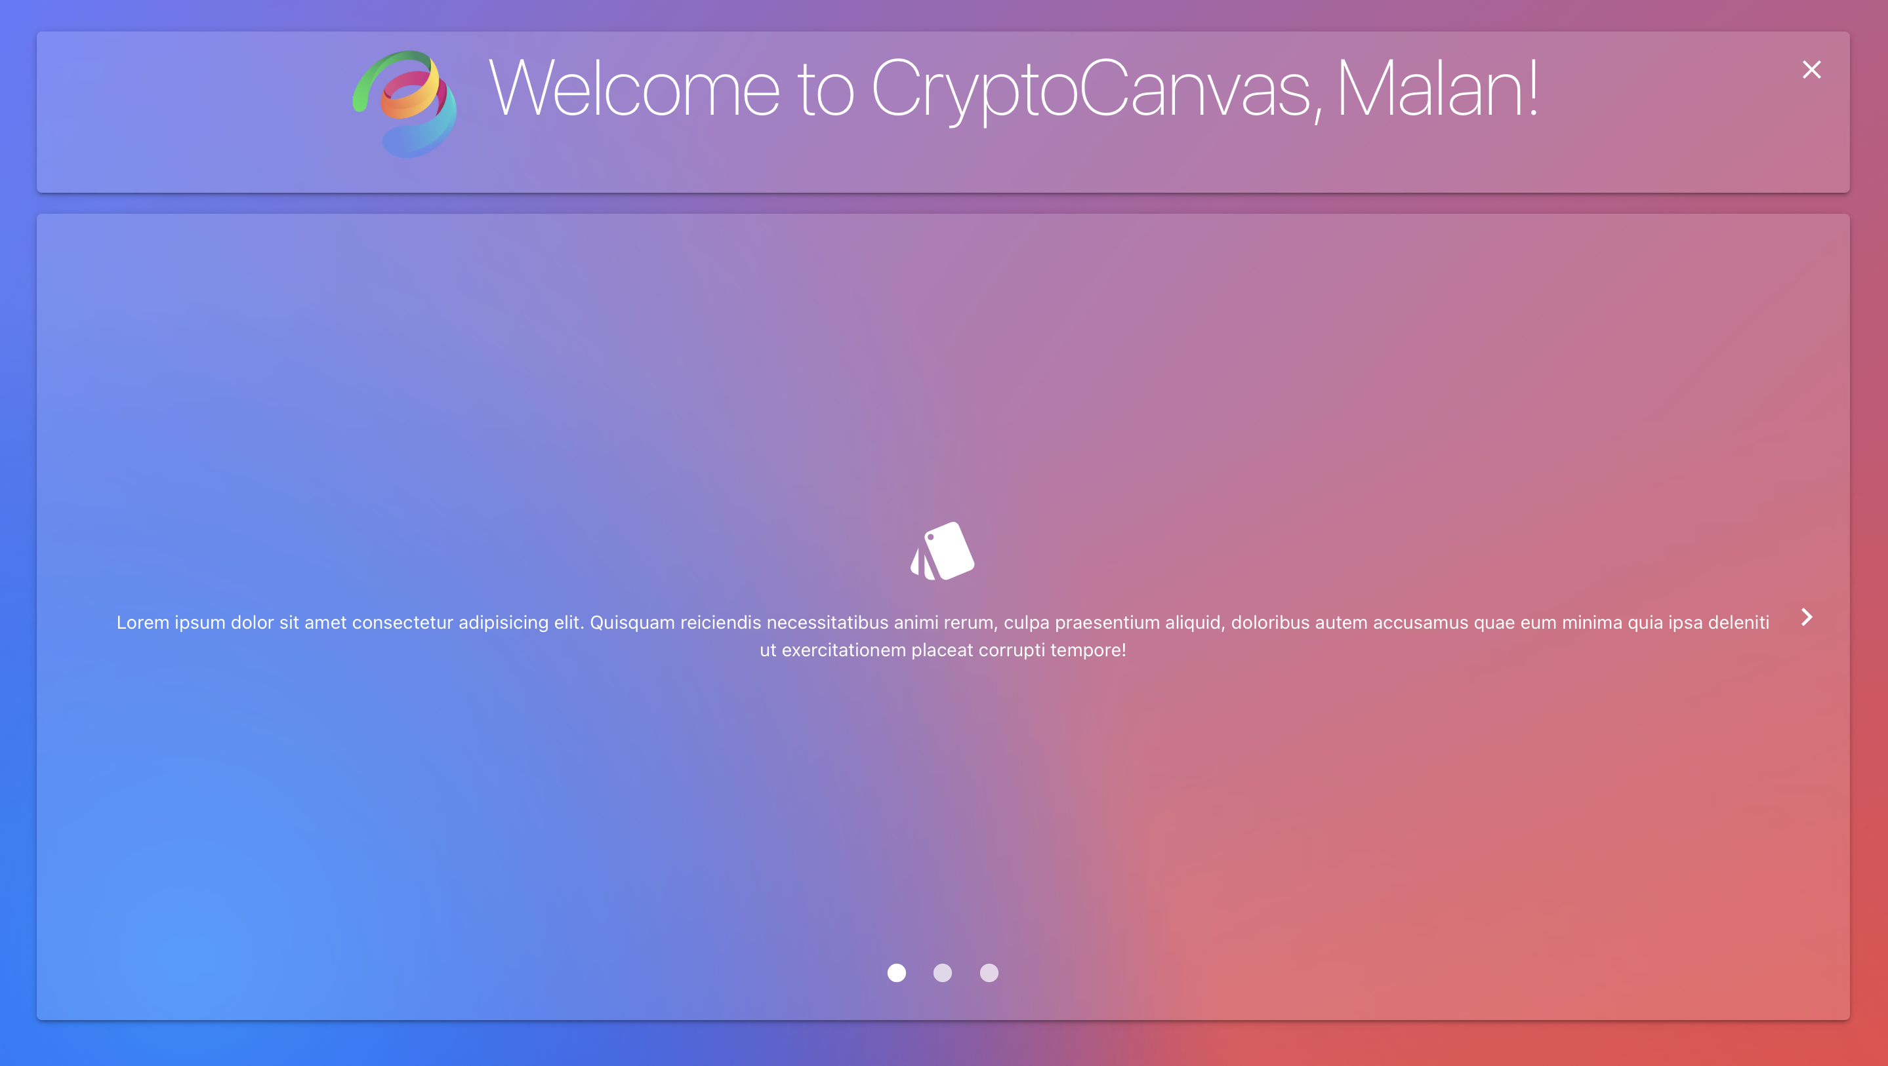

* Changed the toolbar to have the following buttons
  + Tutorial to access the tutorial again
  + Add a widget for choosing a widget to add to dashboard
  + Remove a widget to toggle bulldozer for deleting widgets
  + My dashboard to manage dashboard defaults and dashboard data
  + My account to manage account details
  + Signout button



* Changed the canvas area to look like this:

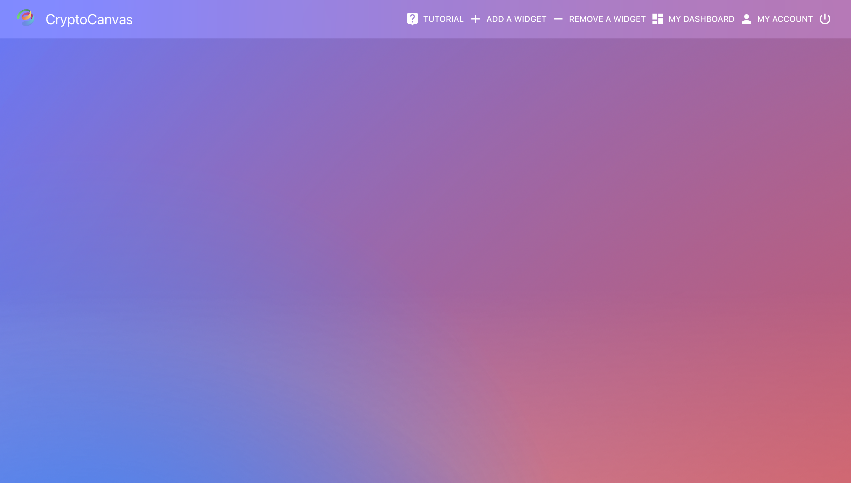

* Changed popup dialogs to have a frosty glass feel… Changed text to white rather than black. Changed buttons to have thin outline consistently throughout the web application.
* Still need to add preview images.

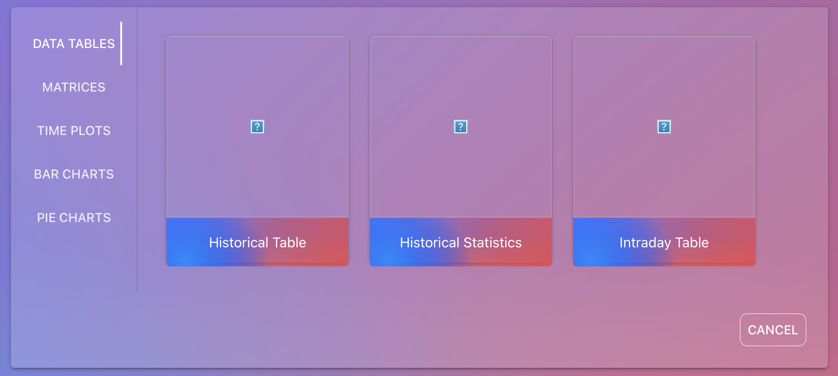

* Introduced Data Collections where the user can now store sets of data in their data collections, add a favorite etc. This allows users to quickly set up a widget with pre defined datasets.

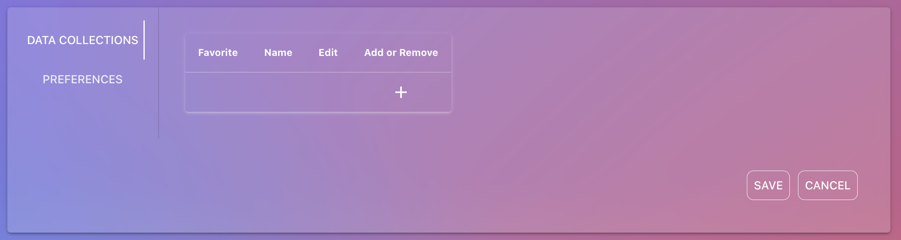

* Menu for user preferences to allow for set widget styling… UI and some fields still needs to be added

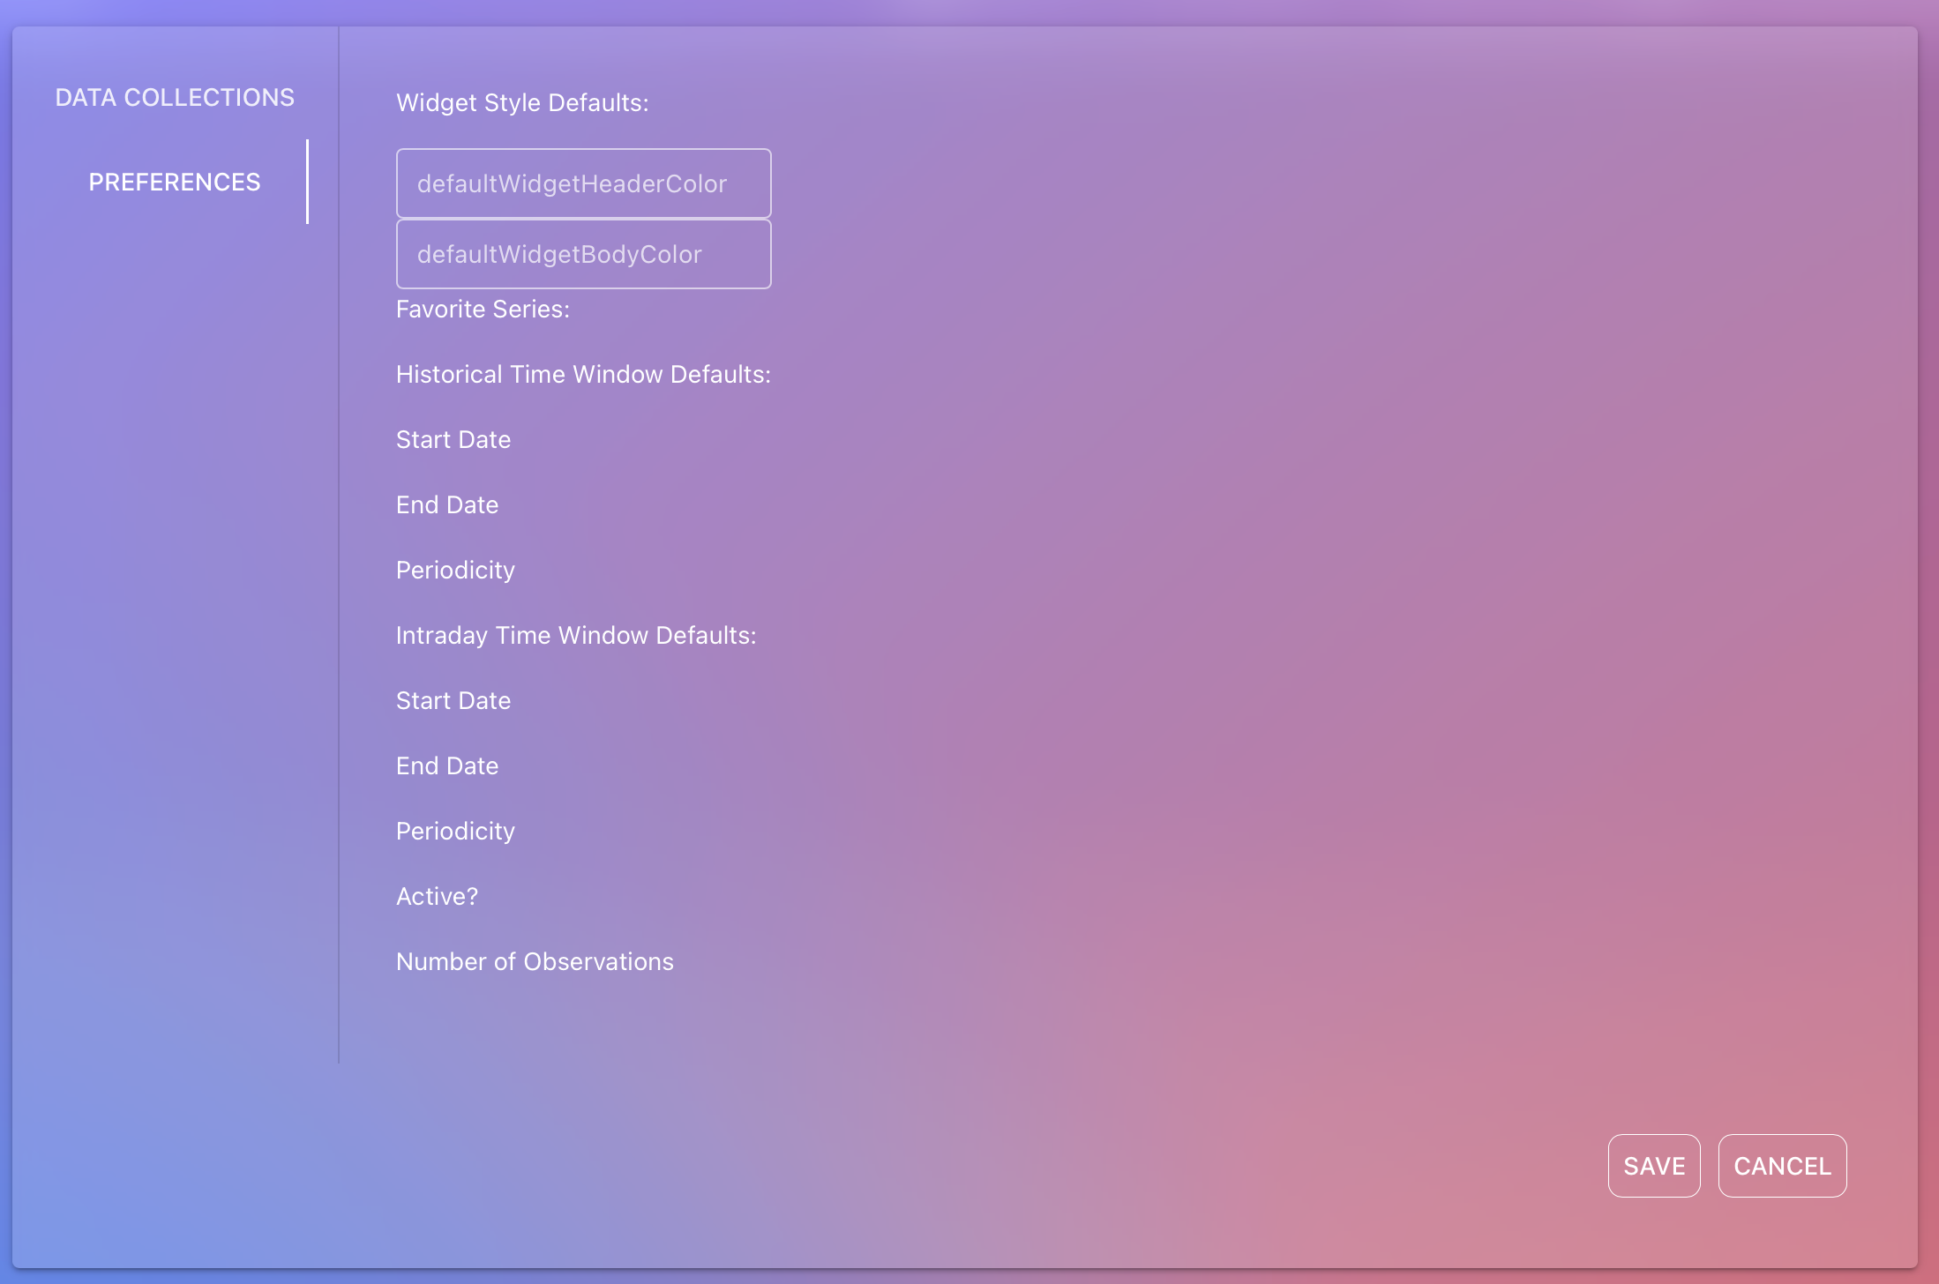

* My account dialog box to change user details… still need to delete user preferences from this dialog

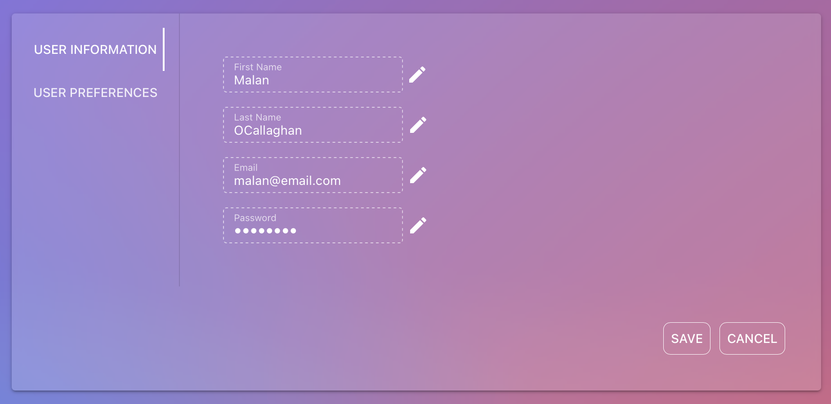

* Widgets also now have a glass like vibe to it

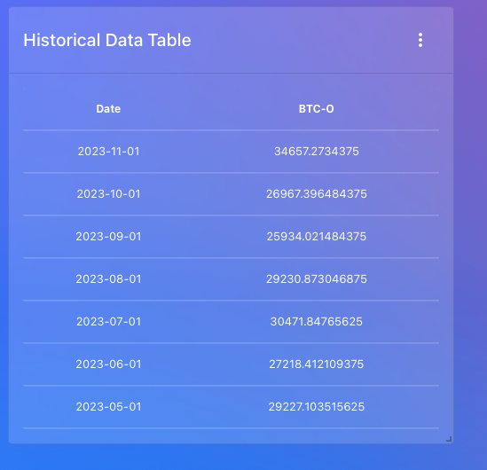

* Edit widget data to be changed so that users only need to select from a list of predefined datasets.
* Widget Styling was improved to make it more interactive. Clicking on any element will create an edit popup where style for it can be configured:

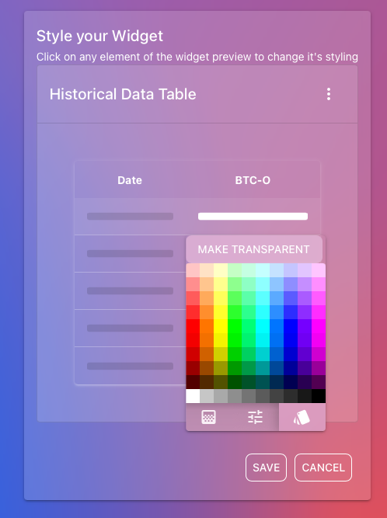

* Changed the background to something more neutral:

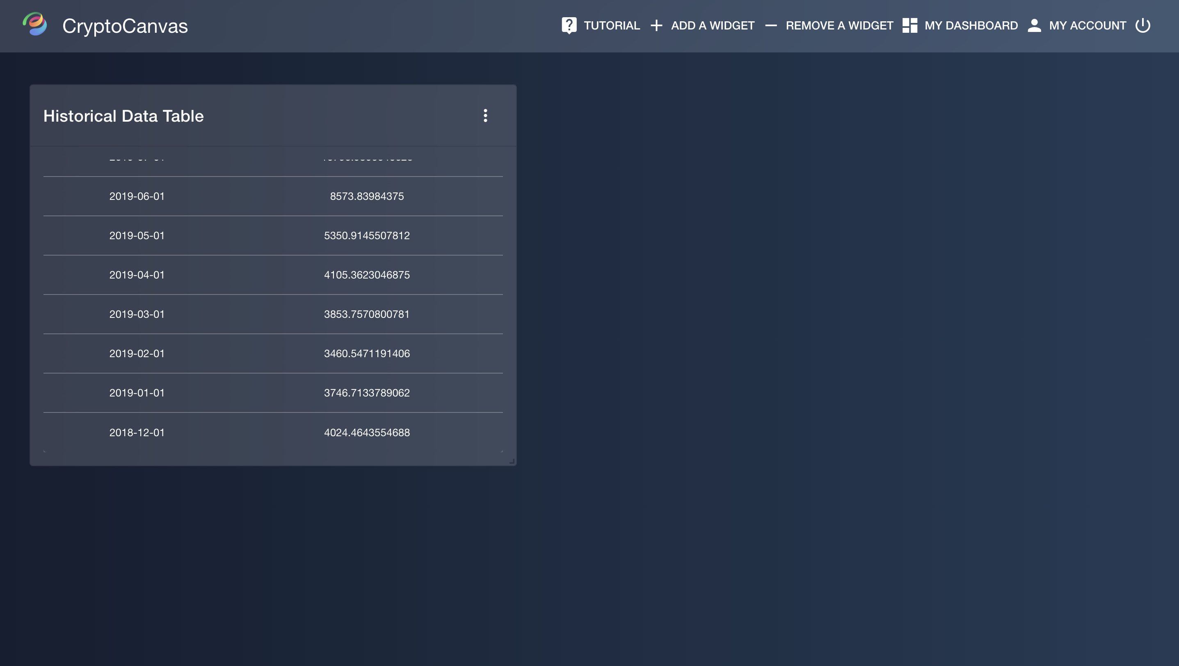

* Added the ability to quickly change to a defined collection of data

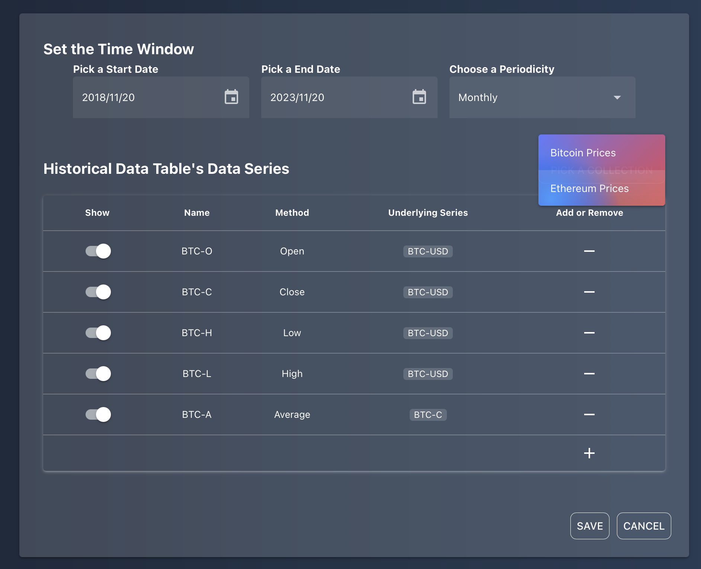

# Welcome Tutorial Content

## Welcome Slide

**Introduction to Cryptocanvas: Your Personalized Crypto Dashboard**

Welcome to CryptoCanvas, your gateway to a dynamic and highly flexible cryptocurrency analysis experience! Whether you're a crypto enthusiast, investor, regulator, or entrepreneur, CryptoCanvas empowers you to explore the world of cryptocurrencies in a way that suits your unique needs and preferences.

**Unleash Your Imagination:**

CryptoCanvas is not your ordinary dashboard — it's a canvas for your creativity in crypto analysis. Whether you're just starting or delving into complex statistical experiments, CryptoCanvas is designed to be user-friendly for beginners while offering in-depth customisation for experienced users.

**Tailor Every Detail:**

With customisability at its core, CryptoCanvas introduces a range of widgets to analyse different aspects of cryptocurrencies. Choose from various widget types and tailor them to your liking. Customise the data using tickers, periodicity, time intervals, and real-time updates. Adjust appearance settings such as colours, widget names, resizing, and positioning on the dashboard. Save your preferences as defaults to streamline your interactions with the application.

**Beyond Ordinary Data:**

Say goodbye to plain fields of static data. CryptoCanvas empowers you to create and visualise any type of data related to cryptocurrencies. Break free from limitations and explore the vast possibilities of crypto data analysis.

**Flexibility Redefined:**

CryptoCanvas is all about flexibility. Tailor your dashboard exactly to your needs, whether you're tracking market trends, analysing trading strategies, or exploring the latest developments in the crypto world. Your canvas, your rules.

**Sleek and Customizable Design:**

Our colourful logo reflects the essence of customisation, while the sleek dark neutral background adds a touch of sophistication. Default widgets feature a frosted glass design, enhancing the overall aesthetics of your dashboard.

Ready to embark on your CryptoCanvas journey? Let's dive in and discover the endless possibilities of personalised cryptocurrency analysis!

## The Basics

**The Basics of CryptoCanvas**

Welcome to CryptoCanvas, your gateway to a personalised and dynamic cryptocurrency analysis experience. Here are the fundamental elements that make CryptoCanvas your go-to platform for crypto insights:

1. **Widgets and Customization:**
   * CryptoCanvas empowers you to add, customise, and personalise various widgets tailored to cryptocurrencies.
   * Widgets consist of a header and a body section, allowing you to control the content displayed based on selected data and user specifications of the widget styling.
2. **Canvas Area:**
   * Widgets are strategically placed on a vertically compact grid known as the 'Canvas Area.'
   * This area serves as the visual canvas where you can move and resize widgets to create your ideal crypto analysis workspace.
3. **Main Toolbar:**
   * The main application features a toolbar with essential options:
     + **Tutorial:** Launch the welcome tutorial anytime for guidance.
     + **Add a Widget:** Easily incorporate new widgets into the Canvas Area for expanded analysis.
     + **Remove a Widget:** Streamline your dashboard by removing unwanted widgets.
     + **My Dashboard:** Configure your dashboard settings and defaults for a personalized analysis experience.
     + **My Account:** Manage your account details, including name, surname, email and password.
     + **Sign Out:** Securely log out of your CryptoCanvas account.

CryptoCanvas puts the power of cryptocurrency analysis at your fingertips with intuitive customisation options and a user-friendly interface.

## Adding a Widget

**Adding Widgets to Your Dashboard**

Ready to enhance your dashboard with insightful widgets? Follow these simple steps to add widgets and unlock the power of data analysis with CryptoCanvas!

1. **Access the Add Widget Menu:**
   * Click on the "Add a Widget" option in the main toolbar. This opens a menu where you can explore and choose from a variety of widgets to enhance your dashboard.
2. **Choose Widget Class:** Cryptocanvas offers five distinct classes of widgets, each serving a unique purpose:
   * **Data Tables:**
     + Ideal for time series data analysis.
     + Example: Analyse the historical performance of cryptocurrencies over a specific time period, aiding in investment decisions.
   * **Matrices:**
     + Great for correlation and covariance studies.
     + Example: Evaluate the relationships between different cryptocurrencies based on their historical price movements.
   * **Time Plots:**
     + Visualise statistics over time from data tables.
     + Example: Track the price changes of a specific cryptocurrency over the past year, providing insights into market fluctuations.
   * **Bar Charts:**
     + Compare group statistics over a time period.
     + Example: Analyze and compare the average trading volumes of different cryptocurrencies over the last month for trend identification.
   * **Pie Charts:**
     + View proportion statistics.
     + Example: Understand the distribution of market capitalization among different cryptocurrencies, aiding in portfolio diversification.
3. **Choose Widget Subclass:** Dive deeper by selecting a subclass based on your analysis needs:
   * **Historical Widgets:**
     + Display data for periodicities from 1 day to 1 year.
     + Example: Examine the historical performance of a specific cryptocurrency over the past year for long-term investment insights.
   * **Intraday Widgets:**
     + Suited for shorter periodicities (1 minute to 1 day).
     + Example: Monitor real-time price movements of a cryptocurrency throughout the day for short-term trading strategies.

Ready to make your dashboard a hub of insightful crypto analysis? Start adding widgets now!

## Dashboard Layout

**Resizing, Moving and Removing Widgets**

Unlock the full potential of your dashboard by mastering the art of resizing, moving and removing widgets in CryptoCanvas.

1. **Resizing a Widget:**
   * To resize a widget, click on the resize handle (found at the bottom-right corner) and drag it until you reach your desired size. Whether you want a comprehensive overview or a detailed focus, resizing allows you to tailor widgets to your specific needs.
2. **Moving Widgets Across the Dashboard:**
   * Enjoy the flexibility of arranging widgets to suit your analysis flow. To move a widget, click anywhere on the widget and start dragging it across the dashboard. Rearrange widgets effortlessly to create a layout that optimises your crypto analysis workflow.
3. **Removing a Widget:**
   * Need to clear some space on your dashboard? Removing a widget is a breeze:
     + Toggle bulldozer mode by clicking on the 'Remove a Widget' button in the toolbar.
     + Once active, your widgets will jiggle, indicating bulldozer mode is in action.
     + The 'Remove a Widget' button turns red, serving as a warning that bulldozer mode is active.
     + Click on the widget you want to remove, and it's gone!

Master these simple yet powerful techniques to customise your CryptoCanvas dashboard with ease. Now, let's shape your analysis space to match your crypto insights.

## Configuring Widget Contents

**Configuring your Widget Content**

1. **Editing Widget Data:**

* Set Your Time Window:
  + Control the start date, end date, and periodicity of the data to precisely tailor the timeframe displayed on your widget.
  + For intraday widgets, toggle the live widget button for automatic data updates. When live, choose the number of hours to display, as start and end date options disappear.
* Edit Your Widget Series:
  + Toggle the 'show' column to activate or deactivate series on the widget.
  + Remove a series by clicking the remove button; add a series with the plus button.
  + Additionally, there is a ‘Choose a Collection’ button, which will allow you to select a data collection of series that’s already defined. In order to see how to manage your collections, go to the ‘Manage your Dashboard’ page of this tutorial.

**Types of Series:**

* + **Base Series:**
    - These serve as the foundation for all other series.
    - Options include:
      * **Price:** Choose from open, close, high, low values.
      * **Trading Volume:** Explore the volume of trades.
      * **Market Capitalization:** Understand the market value of a cryptocurrency.
    - Choose the corresponding cryptocurrency ticker from the dropdown list.
  + **Calculated Series:**
    - Perform mathematical operations on base series to derive new insights.
    - Options include:
      * **Change:** Calculate the absolute change in value.
      * **Percent Change:** Determine the percentage change.
      * **Sum:** Add values across series.
      * **Difference:** Calculate the difference between two series.
      * **Product:** Multiply values across series.
      * **Quotient:** Divide values across series.
  + **Aggregated Series:**
    - Create statistical summaries of an already defined series by aggregating from a faster periodicity.
    - Options include:
      * **Average:** Calculate the mean.
      * **Total:** Sum up all values.
      * **Variance:** Measure the variability.
      * **Standard Deviation:** Assess data dispersion.
      * **Covariance:** Understand the joint variability of two series.
      * **Correlation:** Explore the relationship between two series.
      * **Mode:** Identify the most frequently occurring value.
      * **Median:** Find the middle value.

**2. Styling Your Widget:**

* Click on 'Style Your Widget' to access the customization menu with a preview of your widget.
  + Widget Header:
    - Click on the header to rename it and choose a background color. Create a distinctive and easily identifiable header for your widget.
  + Widget Body:
    - Click on the body to edit the background color. Choose a color that complements your overall dashboard theme or enhances visibility.
  + Individual Data Series:
    - Click on the visual representation of a data series to select a custom color. Assign unique colors to different series for clarity and improved visual appeal.

Mastering these configurations empowers you to present your cryptocurrency data in a way that is both informative and visually engaging.

## Managing Dashboard Settings

**Managing Your Dashboard**

Simplify your Cryptocanvas experience with powerful default functionality for managing your widgets and data. Here's how you can effortlessly customize your dashboard settings:

1. **Accessing Dashboard Settings:**
   * Click on "My Dashboard" in the main toolbar to open a dialog box with essential settings.
2. **Data Collections:**
   * **Data Collections Tab:**
     + This tab serves as a central hub to manage your data series collections.
     + A table displays your current data collections, each comprising series for quick widget setup.
     + **Edit Collection:**
       - Click the edit button to open a menu (similar to the 'Edit Widget Data' menu) for the selected collection.
       - Here, you can fine-tune the series within the collection.
     + **Remove Collection:**
       - Click the remove button to delete a collection.
     + **Set Default Collection:**
       - Choose a default collection, automatically added to new widgets for streamlined setup.
3. **User Preferences:**
   * **User Preferences Tab:**
     + Customize your user preferences for widget appearance.
     + **Default Header and Body Color:**
       - Set the default header and body colors for your widgets.
       - Ensure a consistent and visually appealing theme across your dashboard.

Effortlessly manage your dashboard-related settings, enhancing your crypto analysis experience with Cryptocanvas.

## Managing Account Settings

**Managing Your Account Settings**

Ensure your Cryptocanvas account reflects your current information with easy-to-use account settings. Follow these steps to manage your account details:

1. **Accessing Account Settings:**
   * Click on "My Account" in the main toolbar to open the account settings dialog box.
2. **Updating Account Details:**
   * In the account settings dialog box, you have the flexibility to modify various account details:
     + **Name and Surname:** Change your displayed name.
     + **Email Address:** Update your email address for communication purposes.
     + **Password:** Enhance security by updating your password.
       - You'll be prompted to type your existing password, new password, and confirm the new password.
       - Click "Save" to update your details or "Cancel" to retain the current information.

Keep your Cryptocanvas account details accurate and secure with easy account settings management.